**SAWTRY VILLAGE NEIGHBOURHOOD PLAN**

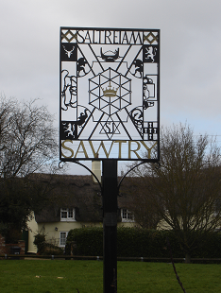

**Have your Final Say!**

**Our Draft Neighbourhood Plan is ready for a pre-consultation stage as described in detail overleaf. This stage will be conducted in a Consultation Period running from 5th December 2022 until 28th January 2023. In that period, you will be able to view the Draft Plan, make any comments, and suggest amendments.**

**The Draft Plan can be viewed online through the Sawtry Parish Council website (**[**https://www.sawtry-pc.gov.uk**](https://www.sawtry-pc.gov.uk) **by tabbing through ‘Planning’ to ‘Neighbourhood Planning’) or at drop-in sessions held in the Old School Hall.**

**This is your final opportunity to influence developments in Sawtry up to 2036.**

**You can help by completing this response form, emailing or writing a letter.**

**Email replies should be addressed to councillor@sawtryneighbourhoodplan.co.uk**

**You may respond as one household, or by submitting individual forms for each adult and each under-18 year old.**

|  |
| --- |
| **Do you have any comments on the Draft Plan?** |
| **(Continue on a separate sheet if necessary)** |

|  |
| --- |
| **Do you wish to suggest any amendments to the Draft Plan?** |
| **(Continue on a separate sheet if necessary)** |

**Please provide one or more of the following contact details:**

|  |  |
| --- | --- |
| **Name** |  |
| **Address** |  |
| **Organisation (If applicable)** |  |
| **Telephone** |  |
| **Email address** |  |

**UK GDPR Privacy Notice: how we shall use your data**

Comments made will become public although personal data will not be made available; the information given will only be used by Sawtry Parish Council and Huntingdonshire District Council for purposes connected with the preparation of the Neighbourhood Plan, including future consultation stages.

**Please return this form to one of the following locations by 28th January 2023:**

**CARESCO** (Shop or Office), **Co-op** Glatton Road, **John Green**, Newsagent, 96 Green End Road,

**Or** deliver it to the Parish Council Office, 37 Green End Road, or to 1 Tinkers Lane, Sawtry.

**This response form can be accessed online using the link: https://forms.gle/4Jp1RZyYaxZUr5az8**

**For help or more copies of this form please contact** [**john.potter@sawtry-pc.gov.uk**](mailto:john.potter@sawtry-pc.gov.uk)